Bylaws
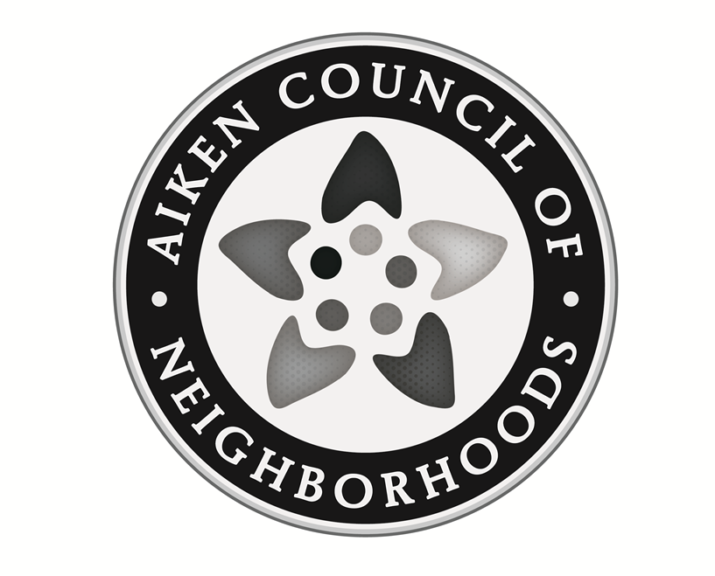
Aiken Council of Neighborhoods
Our Vision
Provide Aiken neighborhoods with the foundation
for healthy, safe, active and inspired living.

Mission
Our Mission is to establish and maintain a network of neighborhood organizations and an effective interface between residents and public agencies in order to identify and solve common problems; provide learning opportunities; recognize and respect diversity and celebrate partnerships as well as victories both large and small.

Bylaws
Aiken Council of Neighborhoods

Article I. Name
The name of the organization shall be the Aiken Council of Neighborhoods (ACON)

Article II. Bylaws
These bylaws constitute the code of rules adopted by the Aiken Council of Neighborhoods for the regulation and management of its affairs.

Article III. Purpose
Section A: The Council of Neighborhoods, functioning as an independent entity separate from the City of Aiken, has as its purpose assisting individual and collective neighborhood organizations through:
- sharing ideas and experiences
- supporting each other’s activities
- continuing a working relationship between the city and Council of Neighborhoods
- assisting with the formation of new neighborhood organizations
- providing educational opportunities for ACON and neighborhood organizations members
Section B: Notwithstanding other provisions set forth herein, the Aiken Council of Neighborhoods shall not engage in any activities which are not permitted to be conducted by:
- an unincorporated association exempt from federal income tax pursuant to section 501(c)(3) of the Internal Revenue Code, or corresponding section of any future federal tax code.
- an unincorporated association to which contributions are deductible pursuant to Section 170(c)(2) of the Internal Revenue Code, or corresponding section of any future federal tax code.
Section C: All fund raising shall be approved by the ACON Executive Committee and shall not violate any city, county, state or federal laws. Donations shall be accepted. Any neighborhood organization seeking funding through ACON’s 501(c)(3) umbrella must present their project for review by and approval from ACON.

Article IV. Policy
The Aiken Council of Neighborhoods is a nonpartisan, nonprofit, non-sectarian organization.

Article V. Area Served
The Aiken Council of Neighborhoods shall concentrate its efforts within the Aiken Department of Public Safety Fire District boundaries.

Article VI. Membership
Section A: Membership in ACON is open to any Aiken neighborhood or homeowner organization that is invited or submits a written request for membership. We encourage organizations to meet the following minimum requirements:
- Hold at least one public neighborhood meeting annually,
- Have contact information (name, address and telephone number) for representatives of the organization on file with the Secretary of the Aiken Council of Neighborhoods,
- While not required for membership in ACON, neighborhood organizations are encouraged to:
- Elect officers or representatives
- Adopt bylaws, a statement of purpose (mission statement) and a vision statement.
Section B: Any organization as defined in Section A is considered eligible for membership in the Aiken Council of Neighborhoods. Membership is granted to the organization, not to an individual. Member organizations are encouraged to name a specific delegate and a minimum of two alternates via correspondence with the Secretary of the Aiken Council of Neighborhoods.
Section C: A member organization of ACON shall have voting privileges in the election of officers of the Council, approving or amending these bylaws or approving general activities of the Council. Each organization shall have ONE vote.

Article VII. Officers and Executive Committee
Section A: Officers of ACON shall consist of the President, Vice President, Secretary and Treasurer.
Section B: The Executive Committee shall consist of the officers, plus the immediate Past President, who shall serve in an advisory capacity.
Section C: Duties of Officers
1. President - The President shall (1) Preside over all meetings of ACON and the Executive Committee, (2) Ruling upon all questions of order, (3) Call Special Meetings of ACON or the Executive Committee as may be deemed necessary, (4) Speak for and represent ACON to other bodies and the news media, or appoint a spokesperson to do so, (5) Appoint Committee members with the advice and consent of the Executive Committee, (6) Co-sign all checks with the Treasurer, (7) Refer matters to appropriate Committees, and (8) except as any such duty may be imposed upon some other member of the Executive Committee by resolution of the Executive Committee, the President shall perform all such duties as are customarily entrusted to and performed by the President of a South Carolina Corporation.
2. Vice President – The Vice President shall (1) Assist the President in the carrying out of the President’s duties, (2) Act in the position of the President in the President’s absence, and (3) Coordinate all committees established by ACON.
3. Secretary - The Secretary shall (1) Act on behalf of the Vice President in their absence, (2) Keep the minutes of all ACON meetings, (3) Prepare and issue any public statements of ACON at the direction of the President, (4) Maintain a list of all in attendance at each ACON meeting, (5) Prepare the meeting agenda as approved by the Executive Committee, (6) Notify all members of all Regular Meetings of ACON at least one week prior to the meeting with all business announced on the agenda, including business required by majority votes at the previous meeting, (7) Maintain membership records for ACON and (8) Certify that all voting representatives are authorized to vote.
4. Treasurer - The Treasurer shall (1) Act on behalf of the Secretary in the Secretary’s absence, (2) Receive and co-disburse, with the President, all funds of ACON, (3) Maintain accurate financial records of ACON, (4) Provide to ACON Members a Financial Report of receipts and expenditures at least bi-monthly, and (5) Prepare a Consolidated Annual Financial Statement of ACON transactions and balances.
Section D: Election of & Terms of Officers
- In order to provide continuity and stability among the executive committee, the election of officers shall be for two-year terms and conducted as follows: (a)The President and Secretary shall be elected in even numbered years. (b)The Vice President and Treasurer shall be elected in odd numbered years.
- A Nominating Committee appointed by the President, consisting of the representatives of five ACON Member Organizations, will solicit nominations in writing for the ACON officers from the Member Organizations at least one month prior to the November Meeting. The Nominating Committee will ascertain the nominee’s willingness to serve. A complete list of willing nominees will then be circulated to the ACON Membership at least one week prior to the November Meeting. Additional nominations may be made from the floor at the time of the election; however, the nominee must be present and express their willingness to serve. No more than one candidate may be nominated from any one member organization. Nomination of a single candidate for multiple offices shall not be allowed.
- For the election to proceed, a majority of Member Organizations must be present. Voting for ACON Officers shall be by secret, written ballot. Voting for each office will be carried out on a separate ballot, except when there is only a single nominee for an office, in which case the President may request a unanimous vote. Votes will be tallied and reported by the Nominating Committee.
- No member of the Executive Committee may serve more than three (3) consecutive terms. Re-election is allowed after a minimum 2 (two) year vacancy following the three (3) consecutive terms. Interim elections constitute a full term, no matter the actual length of service.
- Officers will be installed at ACON’s annual meeting in January. Officer’s Terms will normally coincide with the organization’s fiscal year, which coincides with the calendar year.
Section E: Should an Officer be unable to serve for any reason; a replacement can be elected by a majority vote of the Council members present to fill the unexpired term. The President can appoint a replacement if the unexpired term is less than six (6) months. All resignations MUST be addressed to the Aiken Council of Neighborhood President.
Section F: If any member of the Executive Committee misses three consecutive
Executive Committee meetings, without just cause, the Executive Committee shall
request that member’s resignation. A replacement will either be elected or appointed
by the President per Article VII, Section E.

Article VIII. Meetings
Section A: ACON shall meet bi-monthly on the date and at the time determined by the Executive Committee.
Section B: A quorum of five member organizations is required to conduct the
business of the Council at any meeting. Simple majority vote of member
organizations present shall govern the approval of all business items, except as
specified in Article IX and XI.

Article IX. Dues
Each Neighborhood Association may be required to pay annual dues in the amount set by the ACON Executive Committee and approved by two-thirds (2/3) of the ACON Member Organizations.

Article X. Fiscal Year
The fiscal year will be January 1 through December 31.

Article XI. Amendments
1. Any proposed amendment to the Bylaws must be submitted to the membership, in writing, at least 30 (thirty) days in advance of the meeting at which it is to be considered.
2. Amendments to the Bylaws must be approved by the affirmative vote of two-thirds (2/3) of the ACON Member Organizations.

ARTICLE XII. Indemnification
Every person who is or has been a director, officer, staff member, Executive Committee member or member acting within their scope of authority of ACON shall be indemnified by ACON against all expenses reasonably incurred by such person in connection with any action, suit, or proceeding to which any such party may be party defendant, or with which that party may be threatened by reason of, or growing out of, or in relation to that party being or having been a director, officer, staff member, Executive Committee member or member acting within their scope of authority of ACON. For the purpose of this Paragraph, the term “expenses” includes amounts paid in satisfaction of judgments or in settlement, other than amounts paid to ACON itself. ACON shall not, however, indemnify any director, officer, staff member, Executive Committee member or member acting within their scope of authority of ACON in relation to matters as to which that party shall be adjudged liable for gross negligence or gross misconduct in the performance of that party’s duties for ACON. Further, ACON shall not indemnify any officer, director, staff member, Executive Committee member or member acting within their scope of authority of ACON in case of settlement unless such settlement shall be approved by a majority of the Executive Committee of the Corporation then in office other than those involved (regardless of whether or not such majority constitutes a quorum).

Article XIII. Dissolution
Upon the dissolution of the Aiken Council of Neighborhoods, assets shall be distributed for one or more exempt purposes within the meaning of section 501(c)(3) of the Internal Revenue Code, or corresponding section of any of any future federal tax code, as may be designated by the Executive Committee with the majority approval of the full membership.

Article XIV. Continuity
Created: July 23, 2009
Circulated: September 3, 2009, 1st amended: October 1, 2009, February 18, 2010
Ratified: March 25, 2010
Distributed as ratified: April 29, 2010
Amended: January 26, 2016; October 11, 2016; July 25, 2017; May 28, 2018

____________________________ _________________ ____________________________ _________________
SIGNATURE/President Date SIGNATURE/Secretary Date

